Senior Studio
DUSTIN HOON (INSTRUCTOR)
APT. 817 D
Dustin Hoon
‘Fatherhood Series #1’

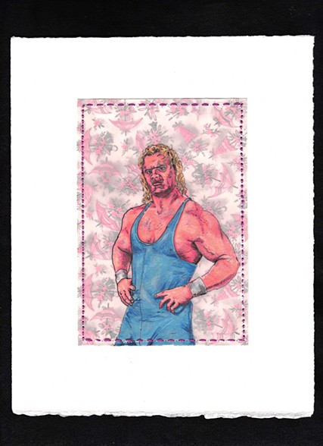
class purpose:
- TO consider what “art” means
- To create and share creations
- To prepare for the world of “visual art” out of the high-school environment
Think of what we are exploring in terms of a conceptual triad
Aesthetics

Creativity exhibition
Student concerns through the semester:
- Aesthetics: why is it important to talk about what is beautiful and/or ugly etc?
- Creativity: how, why, what, where, and for whom are you making art?
- Exhibition: Where will you show your work; and how will you create a body of work to show?
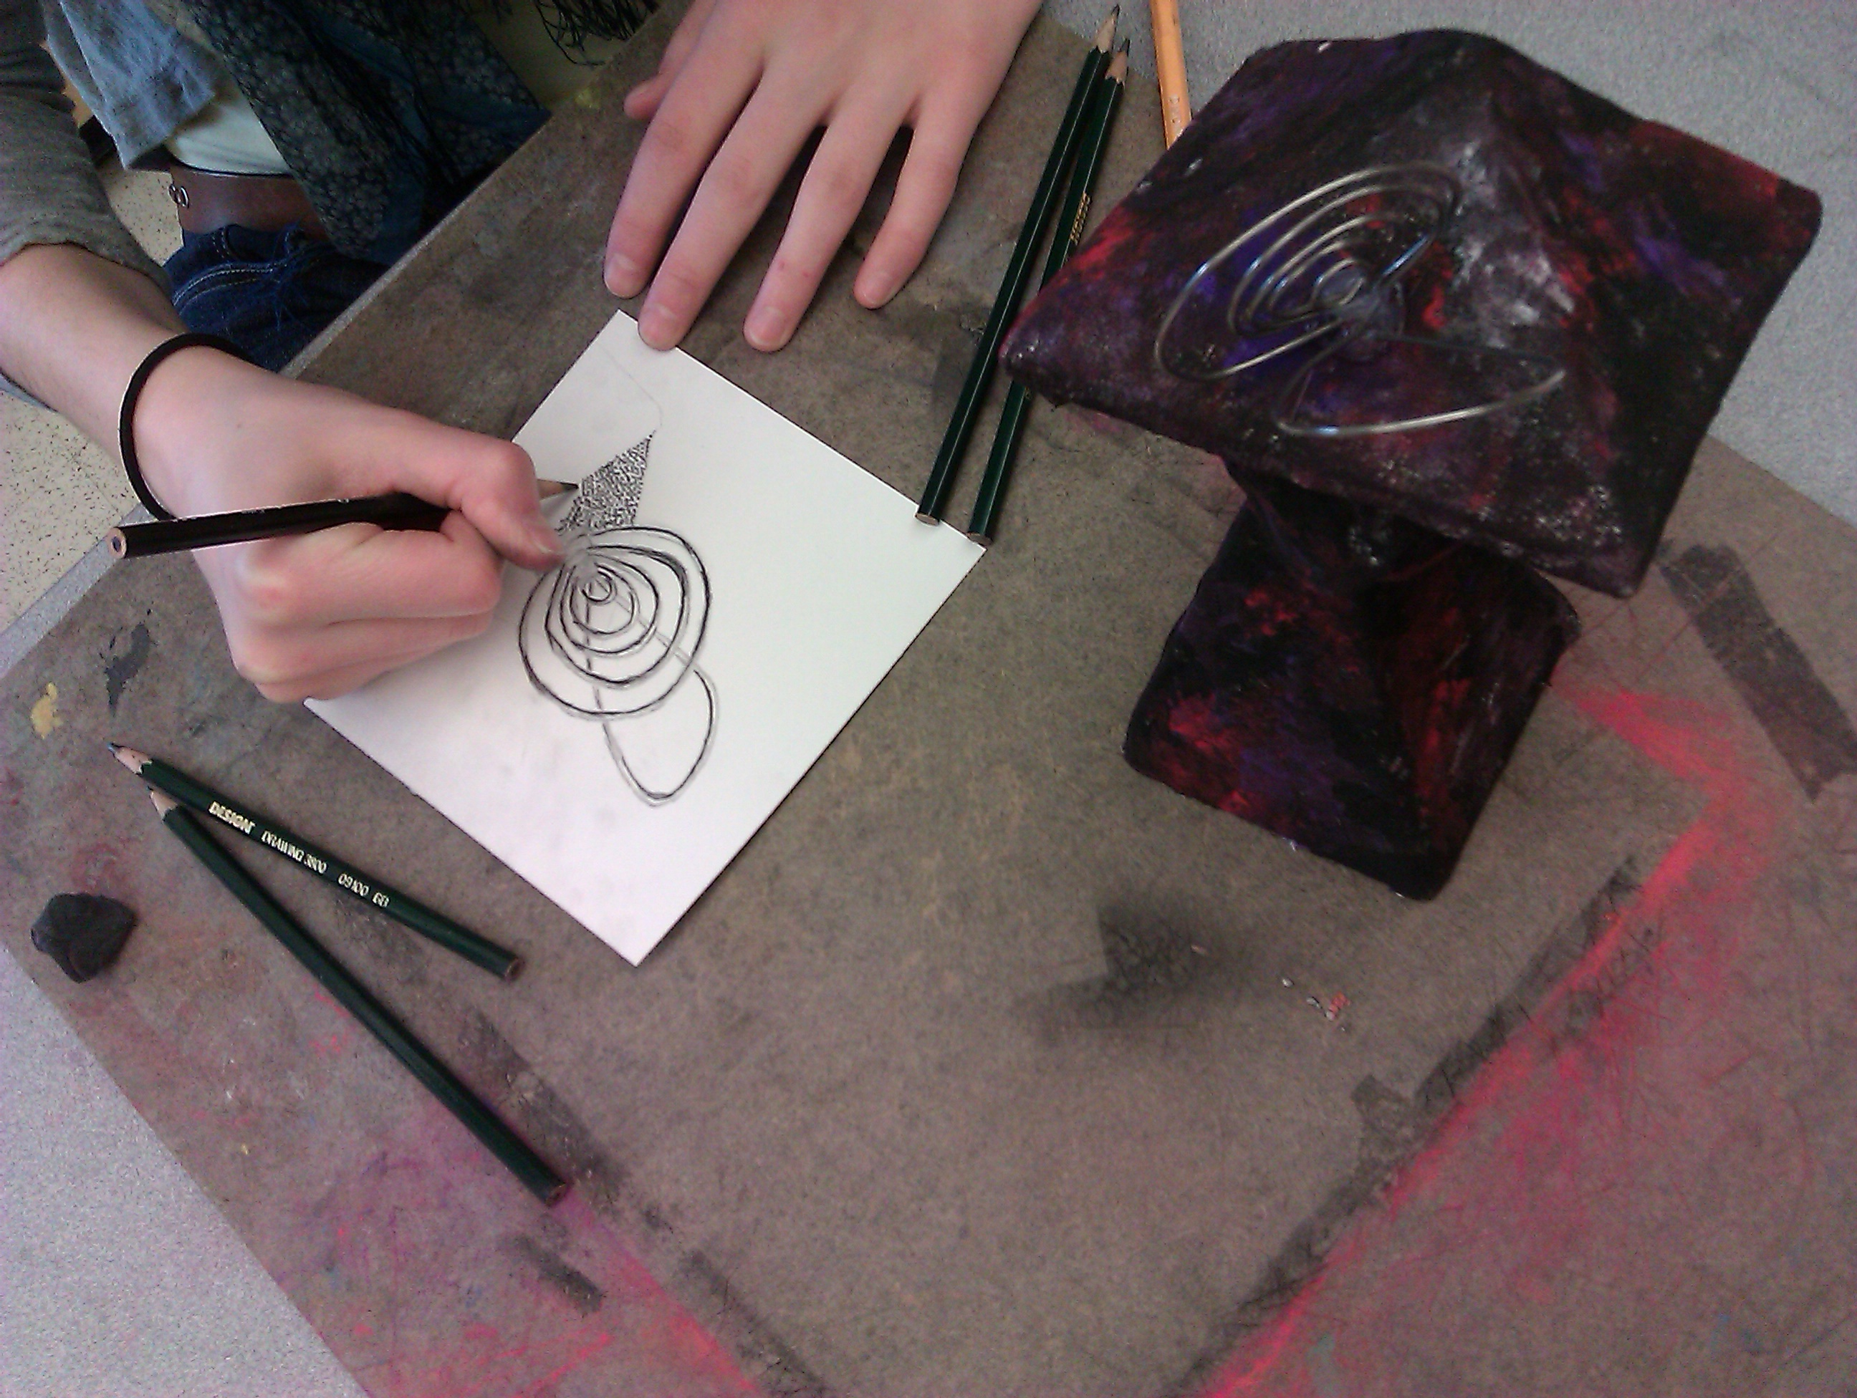
Student at work in Mr. Hoon’s Drawing class 2011

Student expectations:
- Respect: students will show respect for themselves and others in class.
- Students will make art and articulate what it is, why it exists, and what it is about throughout the duration of the class. Students will create a body of work.
- Students will read literature about art, write about art, critique art, and discuss art with others in class. The student must have a sketchbook to this end.

Grading Procedure
Try to think of the class not in terms of grades but in terms of an experience and an opportunity to grow. Having said that Consider the following, as grades are a part of your Grade Point average and a measure of performance in school.
Your instructor is of the opinion that quality of product is more important than speed of completion. Please consider what quality means to you.
All artwork will be accepted until one week prior to the end of the semester without point deduction.
All Principal Assignments, (or major artwork), will be accompanied by an informative assessment tool, (or a Rubric).
All work will have an official due date in order for your instructor to assess, evaluate, and comment on your work. Also, consider trying to meet the due dates in order to get points for critique.
Types of Assignments:
Sketchbook Work: Notes, Drawings, Writing, ETC.
Principal Assignments: your personal work or assignments (main Artwork).
Critique: Discussion and group assessment of student work. We will have a group critique approximately every two weeks
Readings, Writings and Discussion
All of your work will support and evolve into a body of work (or a Portfolio), which will be exhibited for public view
Remember, this class is about: you, art and us. Enjoy the Freedom

